**ABSTRACT**

The global expansion of products invariably introduces risks, including the proliferation of counterfeit items and product duplication, posing significant threats to a company's reputation, revenue, and customer satisfaction. The illicit trade and marketing of fake products are on the rise, adversely impacting sales, brand reputation, and overall profits. This trend also poses a serious danger to unsuspecting buyers. To effectively address the identification and traceability of counterfeit goods throughout the supply chain, a comprehensive blockchain system is proposed.

The implementation of such a blockchain system offers several advantages to companies. Notably, it involves minimal transaction fees, alleviating concerns about delivering counterfeit products to end-users. The primary victims of counterfeit production, the original manufacturers, face substantial challenges, including brand damage and revenue losses. To ascertain the authenticity of a product, a functional blockchain technology is proposed.

Blockchain operates as a secure, interconnected record of information, creating a tamper-resistant framework. Once a product is stored on the blockchain network, a unique hash code is generated, facilitating the maintenance of comprehensive transaction records and establishing a chain of ownership. This chain of transactions is securely stored as blocks in the blockchain.

In the proposed system, each product is assigned a QR code or barcode generated by the manufacturer, containing detailed information about the product. End customers can easily scan this QR code to access all relevant information about the product. By scanning the QR code or barcode, users can promptly determine the product's authenticity, providing a reliable method to identify genuine products and mitigate the risks associated with counterfeit items.

**Introduction**

When a company embarks on the development of a new product, it is confronted with various risks that could jeopardize its reputation, revenue, and customer satisfaction. Among these risks, counterfeiting and replication stand out as significant threats. The widespread availability of counterfeit goods in the market poses a substantial challenge to businesses. In response to this challenge and with the aim of ensuring the effective identification and tracking of fake products, a comprehensive blockchain system is proposed.

This proposed solution is designed to require minimal effort from companies, alleviating their concerns regarding counterfeit products. Counterfeit items not only impose financial losses on manufacturers but also inflict damage on the company's reputation and brand value. Moreover, consumers often mistake these fraudulent products for genuine ones, leading to misleading reviews based on experiences with counterfeit items. To address these issues, the implementation of a blockchain-based system emerges as a viable solution.

Blockchain technology, renowned for its decentralized and distributed nature, operates by storing data in interconnected blocks within a secure database. As new data is added, it seamlessly integrates into the existing data chain, thereby enhancing the security and traceability of information. The persistent challenge of counterfeiting in product markets poses significant threats to companies, including potential damage to brand reputation, loss of revenue, and diminished customer satisfaction.

The proposition of a fully functional blockchain system serves as a promising avenue in responding to this pressing problem. Grounded in decentralization and distributed ledger principles, this technological framework provides a robust mechanism for addressing the menace of counterfeiting. By leveraging blockchain, companies can significantly improve their ability to identify and track fraudulent products, instilling a greater level of confidence and security in the market.

The implementation of a blockchain-based system requires minimal effort on the part of companies, offering an efficient means to safeguard their products and brand integrity. This transformative approach not only mitigates concerns associated with counterfeit products but also serves as a comprehensive solution that protects against financial losses and preserves the invaluable asset of brand reputation. Counterfeit products, which are often indistinguishable from genuine ones, mislead consumers into submitting reviews based on inaccurate perceptions. To counteract this, a proactive and technologically advanced strategy is necessary.

The blockchain, with its decentralized architecture and secure data storage in interconnected blocks, emerges as a reliable ally in the battle against counterfeiting. As new data is added to the blockchain, it seamlessly integrates with the existing chain of information, creating an immutable and transparent record. This enhances traceability, ensuring that each product's provenance is accurately documented throughout its lifecycle. In essence, the blockchain serves as a digital ledger of trust, offering a solution that not only addresses the immediate problem of counterfeiting but also instills confidence in consumers, thereby fostering a more resilient and secure market environment.

**REVIEW IN LITERATURE**

Satoshi Nakamoto, in reference [2], clarified the concept of a purely peer-to-peer electronic cash system. This visionary idea aimed at enabling online payments to be directly transmitted from one party to another, eliminating the need for reliance on financial intermediaries. A. Funde, as discussed in reference [3], explored the application of IPFS (Inter Planetary File System), a Distributed Web technology, for the purpose of managing product ownership. The foundational security of a blockchain system is rooted in the hash algorithm, as highlighted in reference [4].

N. Alzahrani, in reference [5], introduced the innovative concept of a block-supply chain. This decentralized supply chain leverages blockchain and Near Field Communication (NFC) to effectively detect counterfeiting attacks. Si Chen and their team, as detailed in reference [6], delved into the integration of blockchain technology to enhance supply chain quality management. They presented a framework for blockchain-based quality management within the supply chain.

The QR code, commonly known as "Quick Response" and explained in reference [7], is a 2D matrix code designed to facilitate the storage of a substantial amount of data compared to traditional 1D barcodes. Its attributes include high data storage capacity, rapid scanning, omnidirectional readability, error correction, and various versions. Smart contracts, discussed in reference [8], are self-executing agreements among parties represented as program codes across a distributed, decentralized blockchain network. These contracts enable transactions between untrusted parties without the need for reliance on a central authority. Szabo and Miller made early contributions to the development of smart contracts.

In summary, these references collectively contribute to the understanding and advancement of blockchain technology, smart contracts, and innovative applications like the block-supply chain and QR codes in the realm of electronic transactions and product management.

**PROPOSED METHODOLOGY**

Given the rising prevalence of counterfeit products on a global scale, it becomes crucial to establish a comprehensive application system focused on discerning and identifying these deceptive products. This document presents a proposal for such a system, advocating for the development of a robust application designed to effectively recognize and combat the proliferation of counterfeit products in the market. The proposed approach involves the utilization of QR codes for product verification and the addition of relevant information.

To ensure the integrity and immutability of product data, a system is required that prevents unauthorized modifications to existing information. This objective can be achieved through the incorporation of blockchain technology. In the envisioned system, blockchain and QR codes work in tandem to detect and combat the presence of counterfeit products.

In summary, the proposed system employs a combination of blockchain and QR codes to create a powerful tool for identifying and addressing the challenges posed by counterfeit products in the market. This integrated approach seeks to enhance transparency, traceability, and security in the identification of genuine products, ultimately contributing to a more trustworthy marketplace.

**SYSTEM MODEL**

In the proposed system model, the implementation of blockchain is carried out through the use of Ganache, a specialized software designed for this purpose. Ganache plays a crucial role in facilitating the development of a dedicated blockchain network, effectively managing transactions within the system. As a vital component for interacting with the Ethereum blockchain, Ganache serves as an essential tool.

Metamask, operating as a web browser extension, functions as the intermediary bridging the web page and the blockchain. Its role enhances the user interface, ensuring seamless interaction between the user and the blockchain components, contributing to a smoother overall experience.

To develop the web page, the system leverages node.js, a JavaScript runtime environment. Simultaneously, the creation of blockchain smart contracts is achieved through the use of the Solidity programming language. This holistic integration of technologies establishes a robust framework for the detection of counterfeit products. It combines the inherent security features of blockchain with the practicality of QR codes, resulting in a reliable and transparent system.

In essence, the proposed system employs a cohesive blend of Ganache, Metamask, node.js, and Solidity to create a well-integrated and effective solution for detecting and addressing counterfeit products. This approach ensures not only the security of transactions but also provides a user-friendly interface for enhanced interaction and transparency within the blockchain network.

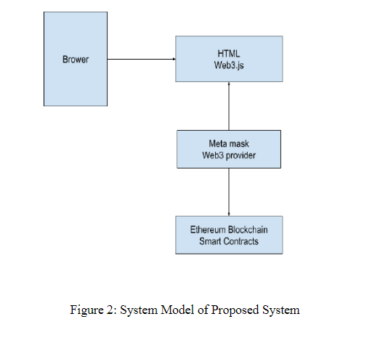

**TOOLS REQUIREMENT**

**Ganache:** is a comprehensive software suite designed for setting up a personal Ethereum blockchain. Its primary function is to deploy the blockchain to the network and facilitate the stimulation of the Ethereum blockchain. This allows users to interact seamlessly with their smart contracts within the blockchain environment.

**Metamask:** is a web browser extension serving as an interface between the browser and the Ethereum blockchain. It plays a crucial role in enabling users to utilize their Ethereum blockchain wallet, enhancing the overall user experience and accessibility.

**Truffle Suite:** functions as a framework that aids in the establishment of an environment for writing smart contracts within the blockchain. It provides tools and resources to streamline the development process, making it more efficient and user-friendly.

**Node.js:** is a framework employed for the development of the web page of the website. Its usage ensures the creation of a dynamic and responsive web interface, contributing to an enhanced user experience.

**Solidity:** identified as a programming language, is specifically utilized for writing smart contracts within the blockchain. It serves as the coding language that enables the definition and execution of smart contract logic, contributing to the functionality of the overall blockchain system.

In summary, the combination of Ganache, Metamask, Truffle Suite, Node.js, and Solidity forms a comprehensive ecosystem for the development and interaction within a blockchain network. These tools collectively contribute to the efficiency, security, and user-friendliness of the blockchain-based application.

**Flow of the Proposed System:**

Stage 1: Product Registration Process:

In this initial stage, the manufacturer initiates the product registration process by adding the product to the blockchain database. A unique QR code is assigned to the product, facilitating the addition of new data.

Stage 2: Distributor Chains:

Following the product registration, the manufacturer ships the product to the distributor. Upon receiving the product, the distributor scans the QR code, adding essential details to the blockchain network. These details encompass product ownership, timestamp, and date, creating a comprehensive record.

Stage 3: Retailer Chains:

Upon reaching the retailer, the product is received from the distributor. The retailer then scans the designated QR code associated with the product, contributing to the ongoing chain of information stored in the blockchain.

Stage 4: End User:

The final stage involves the end user, the customer, who acquires the product. To verify the authenticity and access detailed information, the customer visits the website and uploads the QR code. This action grants them access to a comprehensive history of the product, spanning from the manufacturer to the last retailer in the supply chain.

This system effectively manages the ownership status of a product, commencing with the manufacturer and recording the entire history of ownership. At each stage of the supply chain, from manufacturer to distributor to retailer, new information is added to the blockchain. This process ensures transparency and empowers end-users to verify the authenticity of the product before making an informed purchase decision.

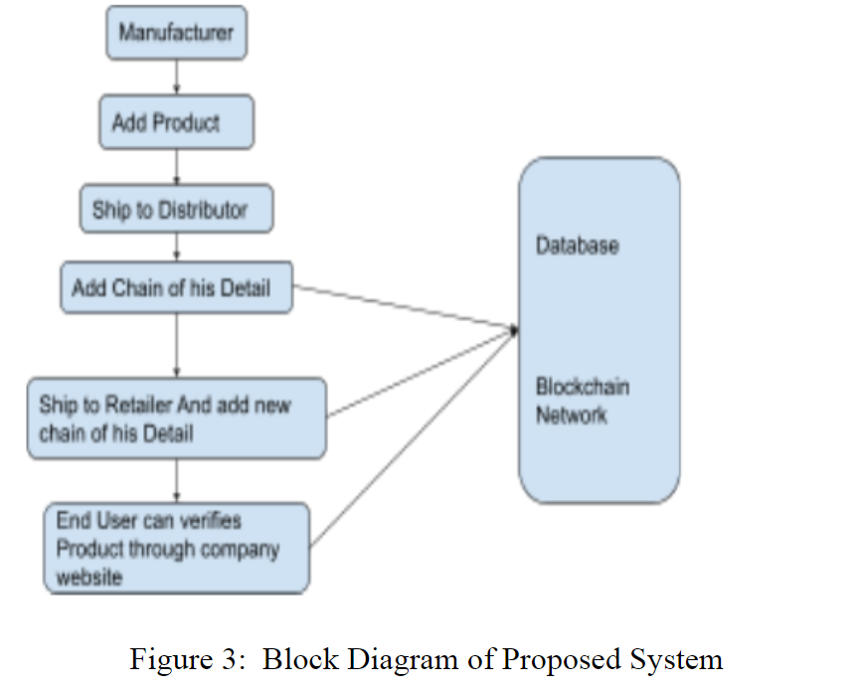

**RESULT AND DISCUSSION**

The proposed system facilitates interaction for both manufacturers and suppliers to add their respective blocks containing transaction details to the blockchain without altering others' blocks. The contracts for the manufacturer and supplier blocks are coded using Solidity. For local testing, Ganache is employed, as the code runs on a local network. The configuration of the host "127.0.0.1" and port 7545 is specified in the true-config.js file.

Contracts are compiled and deployed using Truffle, with migration files created for deployment. Migrations files serve the purpose of deploying contracts on the Ethereum blockchain network. The system's interface is developed using React. Interaction with the Ethereum blockchain is enabled through the Web3.js library, allowing actions such as sending ether, confirming transactions, and reading and writing data from smart contracts.

Metamask, installed as a browser extension, functions as a wallet to interact with the Ethereum blockchain. It enables access to the Ethereum wallet through a browser. Accounts from Ganache are imported into Metamask. To add supplier and manufacturer blocks, users must confirm transactions using their Metamask wallet, connected through Web3.js. The end-user can subsequently verify the supply chain by scanning the QR code to assess the product's integrity. This integrated approach ensures a secure and transparent interaction with the Ethereum blockchain throughout the supply chain.

**CONCLUSION**

In this paper, we introduce a fully functional application designed to assist users in distinguishing between counterfeit and authentic products. The manufacturer initiates the process by storing the product details in the blockchain and generating an embedded QR code. Subsequently, other parties involved add their ownership details upon receiving the product. Ultimately, customers can scan the QR code to review the product's history and determine its authenticity. This innovative application contributes significantly to the expansion and protection of the retail market, instilling confidence in end-users and preserving manufacturers' reputation and corporate value.

In the dynamic landscape of technological advancements, blockchain emerges as a pivotal force, providing heightened security and functionality for stored data. The integration of a blockchain-based application serves as a transformative tool, acting as a safeguard for both consumers and manufacturers. Leveraging the decentralized and secure features inherent in blockchain technology, this application effectively counters fraudulent products, fosters trust, and reinforces the integrity of the retail environment.

Fundamentally, the adoption of blockchain-based applications represents a proactive and effective measure in the ongoing battle against deceptive practices. Its ability to establish an unalterable record of product authenticity not only boosts consumer confidence but also acts as a stronghold for manufacturers, safeguarding their corporate standing and intrinsic value. As we navigate the complexities of the contemporary technological landscape, it becomes increasingly evident that blockchain serves as a linchpin, ensuring the authenticity, security, and sustained growth of the retail sector.

Derived from the aforementioned discourse, it can be asserted that crafting a comprehensively operational application capable of discerning the genuineness of products significantly contributes to the flourishing of the retail market. This inventive solution not only instills confidence in end-users regarding the authenticity of their purchases but also functions as a crucial element in upholding the esteemed reputation and corporate value for manufacturers.

In the present-day panorama of technological advancements, blockchain takes center stage as an integral provider of augmented security and functionality for stored data. The integration of a blockchain-centric application emerges as a revolutionary force, acting as a life-saver for consumers and manufacturers alike. Leveraging the decentralized and secure features inherent in blockchain technology, this application becomes a potent tool in thwarting fraudulent products, nurturing trust, and reinforcing the integrity of the retail ecosystem.

Essentially, the incorporation of blockchain-based applications denotes a proactive and effective strategy in the ongoing battle against deceptive practices. Its capacity to establish an immutable record of product authenticity not only enhances consumer confidence but also functions as a shield for manufacturers, preserving their corporate reputation and intrinsic value. In navigating the intricacies of the contemporary technological landscape, it becomes increasingly evident that blockchain serves as a cornerstone in guaranteeing the authenticity, security, and continual growth of the retail sector.